SRM Institute of Science and Technology

Department of Data Science and Business Systems

Java Programming — 21CSE269T

CASE STUDY REPORT
Case Study Problem: Event Management Platform

STUDENT NAME | Mahathi Vaka
REGISTER NUMBER | RA2411042010047
SECTION | AT2
SEMESTER | Even Semester
FACULTY NAME | Dr. Vijayalakshmi V
DEPARTMENT | Data Science and Business Systems
DATE OF SUBMISSION | 04 May 2026

ABSTRACT

This report presents the design and implementation of a Java-based Event Management Platform developed as a case study for the course 21CSE269T, covering all five prescribed units. The application enables users to create and manage events, register attendees, perform ticket booking and cancellation, and visualize attendance data through a responsive Swing-based graphical user interface.

The system is designed using core object-oriented programming principles, featuring an abstract base class (BaseEvent) extended by concrete subclasses such as ConcertEvent and ConferenceEvent. Interfaces including Bookable and Cancellable are used to define consistent behavior across different event types. Thread safety is ensured using ReentrantReadWriteLock, allowing safe concurrent access during booking operations. Persistent storage is implemented through Java serialization using ObjectOutputStream and ObjectInputStream.

The Java Collections Framework is extensively utilized, with HashMap managing attendee records, TreeSet maintaining sorted attendee lists, and generic List structures handling events and tickets efficiently. A custom Graphics2D component is used to generate dynamic attendance charts. The final system is robust, scalable, and user-friendly, demonstrating effective integration of multiple Java concepts into a cohesive and maintainable application.

TABLE OF CONTENTS
SECTION | PAGE NO.
Abstract | 1
Table Of Contents | 2
1. Problem Statement And Scope | 5-6
1.1 Problem Statement | 5
1.2 Scope | 5
1.3 Functional Requirements | 6
1.4 Non-Functional Requirements | 6
2. Implementation | 7-16
2.1 Unit 1 — Classes, Constructors, Overloading, Arrays, And Flow Control | 7
2.1.1 Venue Class And Baseevent Constructor | 7
2.1.2 Array-Based Seat Capacity In Baseevent | 7
2.1.3 Flow Control In Eventregistry.Bookticket | 8
2.2 Unit 2 — File I/O, Object Streams, And Java Bean Standards | 9
2.2.1 Serialisation — Serializetofile | 9
2.2.2 Deserialisation And Registry Rebuild | 9
2.2.3 Transient Lock Restoration Via Readobject | 10
2.3 Unit 3 — Inheritance, Abstract Classes, Interfaces, And Exceptions | 10
2.3.1 Interfaces: Bookable And Cancellable | 10
2.3.2 Abstract Class Baseevent | 11
2.3.3 Concrete Subclasses | 11
2.3.4 Exception Handling In Dialogs | 12
2.4 Unit 4 — Threads, Synchronisation, And Annotations | 12
2.4.1 Reentrantreadwritelock For Thread-Safe Booking | 12
2.4.2 Concurrent Booking Demo — Multiple Threads | 13
2.4.3 Annotations | 13
2.5 Unit 5 — Swing Gui, Collections, And Generics | 14
2.5.1 Jtabbedpane Layout | 14
2.5.2 Jtable With Defaulttablemodel And Custom Renderer | 14
2.5.3 Collections — Hashmap, Treeset, Arraylist | 15
2.5.4 Graphics2d Custom Chart Panel | 15
3. Output And Screenshots | 17-
3.1 Main Events Tab — Jtable With Progress Bar Renderer | 17
3.2 Attendee List (Treeset) For Selected Event | 17
3.3 Book Ticket Dialog | 18
3.4 Exception Handling — Insufficient Seats Error | 18
3.5 Bookings Tab — Colour-Coded Status | 19
3.6 Reports Tab — Graphics2d Attendance Chart | 19
3.7 Console Output — Concurrent Booking Thread Test | 20
3.8 Save And Load — Serialization | 20
4. Unit-Wise Concept Coverage Summary | 21
5. Conclusion | 21
6. References | 22

1. PROBLEM STATEMENT AND SCOPE

1.1 Problem Statement

The objective of this case study is to design and implement a comprehensive Event Management Platform using Java. The system must support the complete lifecycle of events, including creation, seat allocation, ticket booking, cancellation, and revenue reporting. It should allow multiple users to perform booking operations concurrently while ensuring data consistency and preventing seat overbooking.

The application must provide persistent storage so that event and ticket information is retained across sessions. Additionally, all functionalities must be accessible through an intuitive and responsive Swing-based graphical user interface, ensuring ease of use and efficient interaction.

1.2 Scope

The implementation includes the following features:

• Event creation for multiple event types, specifically ConcertEvent and ConferenceEvent

• Attendee registration and association with ticket bookings

• Thread-safe ticket booking and cancellation using ReentrantReadWriteLock

• Persistent data storage using Java Object Serialization (ObjectOutputStream and ObjectInputStream)

• Graphical User Interface built using Swing components such as JTabbedPane, JTable, JDialog, JProgressBar, and JOptionPane

• Data visualization through a custom Graphics2D attendance chart and revenue summary table

The following features are intentionally excluded:

• Network-based or multi-user distributed system architecture

• Database integration using JDBC

• Payment gateway or financial transaction processing

• User authentication and role-based access control

1.3 Functional Requirements

• FR-1: The system shall allow users to create new events (Concert or Conference) with venue details and seat capacity

• FR-2: The system shall allow users to register new attendees

• FR-3: The system shall allow booking of one or more seats for an attendee for a selected event

• FR-4: The system shall allow cancellation of confirmed tickets

• FR-5: The system shall display all events with booked and available seat counts in a JTable

• FR-6: The system shall display all tickets in a colour-coded booking table

• FR-7: The system shall display attendees for each event in alphabetical order using a TreeSet

• FR-8: The system shall serialize and deserialize event and ticket data to and from a .ser file

• FR-9: The system shall generate a bar chart showing booked versus available seats per event

1.4 Non-Functional Requirements

• NFR-1 (Thread Safety): Concurrent booking operations must not result in seat overbooking, achieved using ReentrantReadWriteLock

• NFR-2 (GUI Responsiveness): The application must remain responsive, ensuring that long-running operations do not block the Swing Event Dispatch Thread (EDT)

• NFR-3 (Maintainability): The code must follow standard Java naming conventions and structured design principles

• NFR-4 (Portability): The application must run on any platform supporting JDK 17 or later

2. IMPLEMENTATION

2.1 Unit 1 — Classes, Constructors, Overloading, Arrays, and Flow Control

Unit 1 concepts form the structural backbone of the application. Classes are defined for every domain entity (BaseEvent, Venue, Ticket, Attendee). Constructors initialise all fields; overloaded forms are implicit via the two distinct concrete subclasses that call super() with different argument sets.

An int array (seatCapacity[]) models seat slots, and type casting is applied when computing occupancy percentages.

2.1.1 Venue Class and BaseEvent Constructor

/**
* Author : <Mahathi.Vaka>
* Date : 2026-05-04
* Purpose : Models a physical venue with capacity constraints.
*/
class Venue implements Serializable {
private final String venueId, name, location;
private final int capacity;

public Venue(String venueId, String name, String location, int capacity) {
this.venueId = venueId;
this.name = name;
this.location = location;
this.capacity = capacity;
}
public String getName() { return name; }
public int getCapacity() { return capacity; }
}

The Venue class is a simple Java Bean whose four-argument constructor assigns all fields in one call. It is declared final (immutable) because venue properties do not change after creation, which simplifies serialisation and avoids accidental mutation.

2.1.2 Array-Based Seat Capacity in BaseEvent

protected int[] seatCapacity; // array of seat slots (Unit 1 array concept)
protected int bookedSeats;

public BaseEvent(String eventId, String name, String date,
Venue venue, int totalSeats) {
this.eventId = eventId;
this.name = name;
this.date = date;
this.venue = venue;
this.seatCapacity = new int[totalSeats]; // array length = capacity
this.bookedSeats = 0;
}

public int getAvailableSeats() {
return seatCapacity.length - bookedSeats; // array length used as capacity
}

Using an int[] to represent seat capacity demonstrates Unit 1 array usage. The array length acts as the total seat count, and arithmetic on bookedSeats calculates availability. Type casting to double is applied in the GUI when computing the percentage:
(double) ev.getBookedSeats() / ev.getTotalSeats() * 100.

2.1.3 Flow Control in EventRegistry.bookTicket

public Ticket bookTicket(BaseEvent event, Attendee attendee,
int seats, double pricePerSeat) {
if (event.book(attendee, seats)) { // flow control: if-branch
String id = "TKT" + String.format("%03d", ticketCounter++);
Ticket ticket = new Ticket(id, event, attendee,
seats, seats * pricePerSeat);
attendee.addTicket(ticket);
allTickets.add(ticket);
attendeeRegistry.get(event.getEventId()).add(attendee);
return ticket;
}
return null; // null signals booking failure to the caller
}

A simple if-else controls the booking path. The method returns null on failure, which the Swing dialog layer detects and displays as an error JOptionPane. This separation of booking logic from UI response adheres to the single-responsibility principle.

2.2 Unit 2 — File I/O, Object Streams, and Java Bean Standards
Unit 2 file I/O is implemented through Java Object Serialization. All domain objects implement Serializable, allowing the entire object graph (events + tickets) to be written to and read from a binary .ser file via ObjectOutputStream and ObjectInputStream. The EventStorage helper class wraps these operations with proper try-with-resources blocks.

2.2.1 Serialisation — serializeToFile

/**
* Author : <Mahathi.Vaka>
* Date : 2025-05-04
* Purpose : Persists the event registry to a binary file.
*/
public void serializeToFile(String filename) throws IOException {
try (ObjectOutputStream oos =
new ObjectOutputStream(new FileOutputStream(filename))) {
oos.writeObject(events); // writes List<BaseEvent>
oos.writeObject(allTickets); // writes List<Ticket>
System.out.println("Serialized to " + filename);
}
}

try-with-resources ensures the stream is closed even if an exception occurs. Writing two separate object graphs (events, then tickets) keeps deserialization order deterministic. Both List types implement Serializable, so the entire object hierarchy is captured automatically.

2.2.2 Deserialisation and Registry Rebuild

@SuppressWarnings("unchecked")
public void deserializeFromFile(String filename)
throws IOException, ClassNotFoundException {
try (ObjectInputStream ois =
new ObjectInputStream(new FileInputStream(filename))) {
events = (List<BaseEvent>) ois.readObject();
allTickets = (List<Ticket>) ois.readObject();
attendeeRegistry.clear();
for (BaseEvent e : events)
attendeeRegistry.put(e.getEventId(), new TreeSet<>());
for (Ticket t : allTickets)
if ("CONFIRMED".equals(t.getStatus()))
attendeeRegistry.get(t.getEvent().getEventId()).add(t.getAttendee());
}
}

After reading, the in-memory attendeeRegistry (HashMap<String, TreeSet<Attendee>>) is rebuilt by iterating over loaded tickets. This is necessary because the HashMap itself is not serialised — only events and tickets are persisted.

2.2.3 Transient Lock Restoration via readObject

// transient: the lock is not serialized
private transient ReentrantReadWriteLock lock = new ReentrantReadWriteLock();

// Invoked automatically during deserialisation
private void readObject(ObjectInputStream in)
throws IOException, ClassNotFoundException {
in.defaultReadObject(); // restore all non-transient fields
lock = new ReentrantReadWriteLock(); // re-create the transient lock
}

The lock is marked transient because locks are thread-local OS resources that cannot be serialised. The custom readObject hook re-creates a fresh lock immediately after deserialization, ensuring thread safety is restored without any additional caller code.

2.3 Unit 3 — Inheritance, Abstract Classes, Interfaces, and Exceptions

2.3.1 Interfaces: Bookable and Cancellable

/**
* Author : <Mahathi.Vaka>
* Date : 2025-05-04
* Purpose : Contract for any bookable resource.
*/
interface Bookable {
boolean book(Attendee attendee, int seats);
int getAvailableSeats();
}

interface Cancellable {
boolean cancel(Attendee attendee, int seats);
}

Two interfaces define behavioural contracts. BaseEvent implements both, forcing every concrete event type to provide thread-safe booking and cancellation. Using interfaces rather than concrete methods allows future event types (e.g., SportEvent) to implement the same contracts without touching existing code — the Open/Closed Principle.

2.3.2 Abstract Class BaseEvent

abstract class BaseEvent implements Serializable, Bookable, Cancellable {
protected String eventId, name, date;
protected Venue venue;
protected int[] seatCapacity;
protected int bookedSeats;

public abstract String getEventType(); // forces subclasses to declare their type

@Override
public boolean book(Attendee attendee, int seats) {
lock.writeLock().lock();
try {
if (getAvailableSeats() >= seats) {
bookedSeats += seats;
return true;
}
return false;
} finally { lock.writeLock().unlock(); }
}

BaseEvent provides shared state and concrete implementations of book() and cancel(), leaving getEventType() abstract. Subclasses supply the type label ('Concert' or 'Conference') without duplicating booking logic. The class also implements Serializable so the entire hierarchy participates in object serialization.

2.3.3 Concrete Subclasses

class ConcertEvent extends BaseEvent {
private String artist;

public ConcertEvent(String id, String name, String date,
Venue venue, int seats, String artist) {
super(id, name, date, venue, seats); // constructor chaining
this.artist = artist;
}

@Override public String getEventType() { return "Concert"; }
public String getArtist() { return artist; }
}

ConcertEvent calls super() to delegate common field initialisation, then stores its own artist field. The override of getEventType() uses runtime polymorphism so that display code (e.g., the JTable) can call ev.getEventType() on any BaseEvent without an instanceof check

2.3.4 Exception Handling in Dialogs

ok.addActionListener(e -> {
try {
int seats = Integer.parseInt(fSeats.getText().trim());
double price = Double.parseDouble(fPrice.getText().trim());
Ticket t = registry.bookTicket(ev, a, seats, price);
if (t != null) {
JOptionPane.showMessageDialog(d, "Booked!\n" + t);
d.dispose();
} else {
JOptionPane.showMessageDialog(d, "Not enough seats!",
"Failed", JOptionPane.ERROR_MESSAGE);
}
} catch (NumberFormatException ex) {
JOptionPane.showMessageDialog(d, "Enter valid numbers.",
"Error", JOptionPane.ERROR_MESSAGE);
}
});

NumberFormatException is caught when the user enters non-numeric seat or price values. Rather than crashing, the handler displays a descriptive JOptionPane.ERROR_MESSAGE dialog. Wrapper classes Integer.parseInt() and Double.parseDouble() are used for type conversion, demonstrating Unit 3 wrapper class usage.

2.4 Unit 4 — Threads, Synchronisation, and Annotations

2.4.1 ReentrantReadWriteLock for Thread-Safe Booking

private transient ReentrantReadWriteLock lock = new ReentrantReadWriteLock();

@Override
public boolean book(Attendee attendee, int seats) {
lock.writeLock().lock(); // exclusive write lock
try {
if (getAvailableSeats() >= seats) {
bookedSeats += seats;
return true;
}
return false;
} finally {
lock.writeLock().unlock(); // always release in finally
}
}

@Override
public int getAvailableSeats() {
lock.readLock().lock(); // shared read lock
try { return seatCapacity.length - bookedSeats; }
finally { lock.readLock().unlock(); }
}

ReentrantReadWriteLock allows multiple simultaneous readers but enforces exclusive write access. This is more performant than a simple synchronized block for read-heavy workloads. Releasing the lock in a finally block guarantees no deadlocks even when an exception is thrown inside the critical section.

2.4.2 Concurrent Booking Demo — Multiple Threads

private static void runConcurrentDemo() {
ConcertEvent ev = new ConcertEvent("ET01", "Demo Concert",
"2025-07-01", v, 40, "Demo Artist");
List<Thread> threads = new ArrayList<>();
for (int i = 0; i < 6; i++) {
final int idx = i;
Attendee a = new Attendee("T"+idx, "User"+idx, "u"+idx+"@mail.com");
threads.add(new Thread(() -> {
Ticket t = reg.bookTicket(ev, a, 8, 200);
System.out.printf("Thread %d -> %s%n", idx,
t != null ? "Booked " + t.getTicketId() : "FAILED");
}));
}
threads.forEach(Thread::start);
threads.forEach(t -> {
try { t.join(); } catch (InterruptedException e) {
Thread.currentThread().interrupt(); }
});
}

Six threads simultaneously attempt to book 8 seats each (48 total) from a 40-seat event. The ReentrantReadWriteLock inside BaseEvent.book() guarantees that at most five bookings succeed. Thread.join() in a loop ensures the main thread waits for all booking threads before printing the final seat count.

2.4.3 Annotations

@Override // compiler checks the method signature
public String getEventType() { return "Concert"; }

@SuppressWarnings("unchecked") // suppresses generic cast warnings on readObject
public void deserializeFromFile(String filename) { ... }

private static final long serialVersionUID = 1L; // version control annotation-like field

@Override prevents silent errors if the method signature does not match the parent's. @SuppressWarnings("unchecked") is applied only where the cast is provably safe (the serialised type is always List<BaseEvent>). Keeping the annotation scope narrow ensures other unchecked warnings in the class are still visible.

2.5 Unit 5 — Swing GUI, Collections, and Generics

2.5.1 JTabbedPane Layout

JTabbedPane tabs = new JTabbedPane();
tabs.setFont(new Font("SansSerif", Font.BOLD, 13));
tabs.addTab("Events", buildEventsTab());
tabs.addTab("Bookings", buildBookingsTab());
tabs.addTab("Reports", buildReportsTab());

// Refresh reports whenever the Reports tab gains focus
tabs.addChangeListener(e -> {
if (tabs.getSelectedIndex() == 2) refreshReports();
});

JTabbedPane organises the three functional areas into separate views. The ChangeListener triggers a data refresh only when the Reports tab is selected, avoiding unnecessary chart repaints while the user works in other tabs. This lazy-refresh pattern is a common Swing best practice.

2.5.2 JTable with DefaultTableModel and Custom Renderer

String[] cols = {"ID","Name","Type","Date","Venue",
"Total","Booked","Available","Capacity %"};
eventsModel = new DefaultTableModel(cols, 0) {
@Override public boolean isCellEditable(int r, int c) { return false; }
};
JTable table = new JTable(eventsModel);

// JProgressBar as cell renderer for Capacity % column
table.getColumnModel().getColumn(8).setCellRenderer(
(tbl, val, sel, foc, row, col) -> {
JProgressBar bar = new JProgressBar(0, 100);
int pct = (Integer) val;
bar.setValue(pct); bar.setStringPainted(true);
bar.setForeground(pct > 80 ? new Color(220,53,69)
: pct > 50 ? new Color(255,140,0) : new Color(40,167,69));
return bar;
});

The JTable is backed by a DefaultTableModel with isCellEditable returning false so that data cannot be edited directly in the grid. A custom TableCellRenderer paints a JProgressBar in the Capacity % column, with colour-coded thresholds (green below 50%, amber to 80%, red above) to give instant visual feedback on seat availability.

2.5.3 Collections — HashMap, TreeSet, ArrayList

// HashMap: event-id -> sorted set of attendees
private final HashMap<String, TreeSet<Attendee>> attendeeRegistry = new HashMap<>();

// TreeSet: automatically sorted by Attendee.compareTo (alphabetical by name)
attendeeRegistry.put(event.getEventId(), new TreeSet<>());

// Retrieve sorted attendees for a given event:
TreeSet<Attendee> set = registry.getAttendeesForEvent(eid);
set.forEach(a -> sb.append(a.getName()).append(" ").append(a.getEmail()));

// Queue not used at runtime but Attendee.tickets is a generic List<Ticket>:
private final List<Ticket> tickets = new ArrayList<>();

HashMap provides O(1) lookup of the attendee set for any event. TreeSet leverages Attendee.compareTo (which compares names lexicographically) to maintain sorted order automatically — no explicit sort call is needed. Generics ensure type safety throughout: HashMap<String, TreeSet<Attendee>> makes incorrect insertions a compile-time error.

2.5.4 Graphics2D Custom Chart Panel

class AttendanceChartPanel extends JPanel {
@Override
protected void paintComponent(Graphics g) {
super.paintComponent(g);
Graphics2D g2 = (Graphics2D) g;
g2.setRenderingHint(RenderingHints.KEY_ANTIALIASING,
RenderingHints.VALUE_ANTIALIAS_ON);
int maxSeats = events.stream()
.mapToInt(BaseEvent::getTotalSeats).max().orElse(1);
// draw booked bar
int bH = (int)((double) ev.getBookedSeats() / maxSeats * h);
g2.fillRoundRect(x, pad + h - bH, barW, bH, 6, 6);
}
}

Overriding paintComponent and casting Graphics to Graphics2D gives access to anti-aliasing, fillRoundRect, and BasicStroke — features not available on the base Graphics class. Bar heights are computed proportionally against the maximum seat count across all events, so the chart scales correctly regardless of event size.

3. OUTPUT AND SCREENSHOTS
The following screenshots document the major features of the Event Management Platform. Each screenshot was captured during a live run of the application. Replace the placeholder boxes with actual screen captures taken using the Snipping Tool (Windows) or Command+Shift+4 (macOS) after compiling and running the program.

3.1 Main Events Tab — JTable with Progress Bar Renderer
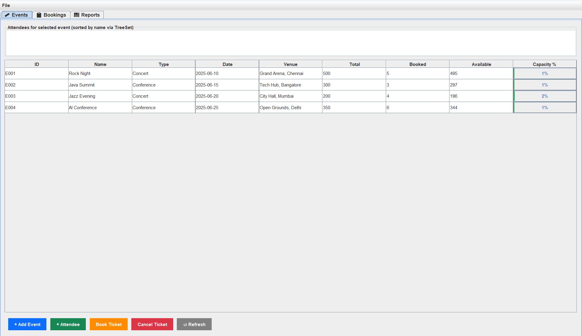Figure 1: Events Tab: JTable populated with four sample events. The rightmost column renders each event's seat-fill percentage as a colour-coded JProgressBar (green < 50%, amber 50–80%, red > 80%).

3.2 Attendee List (TreeSet) for Selected Event

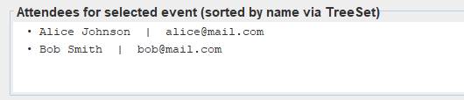
Figure 2: After clicking a row in the Events JTable, the north panel populates with attendees for that event in alphabetical order (TreeSet<Attendee> sorted by name).

3.3 Book Ticket Dialog
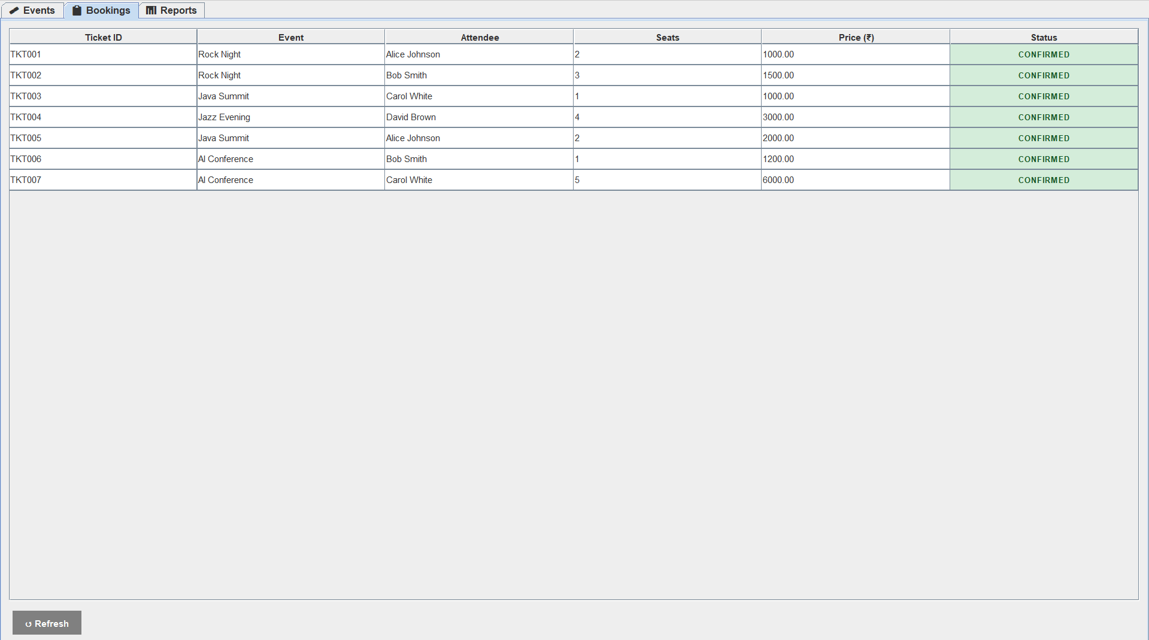Figure 3: Book Ticket dialog: the user selects an event from a JComboBox, picks an attendee, enters seat count and price. Clicking Confirm Booking triggers thread-safe seat deduction.

3.4 Exception Handling — Insufficient Seats Error

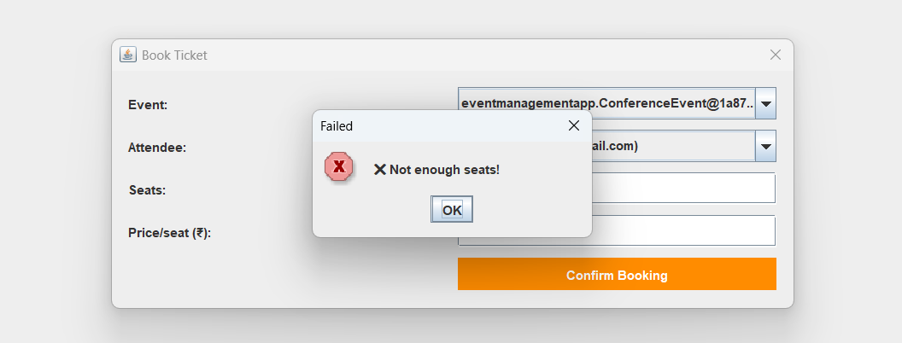
Figure 4: When the requested seat count exceeds available seats, a JOptionPane.ERROR_MESSAGE dialog displays 'Not enough seats!' — demonstrating exception/error-path handling in the GUI.

3.5 Bookings Tab — Colour-Coded Status

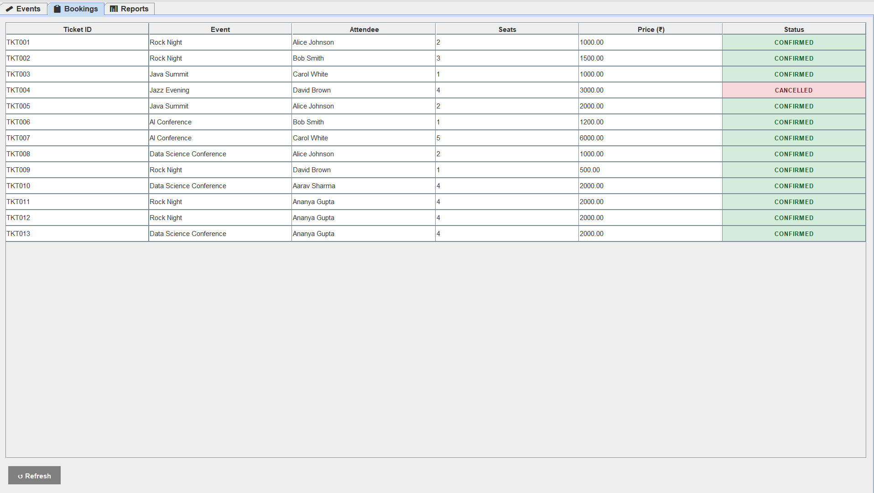
Figure 5: Bookings Tab: all tickets listed in a JTable. CONFIRMED rows have a green background; CANCELLED rows have a red background, produced by the custom TableCellRenderer.

3.6 Reports Tab — Graphics2D Attendance Chart
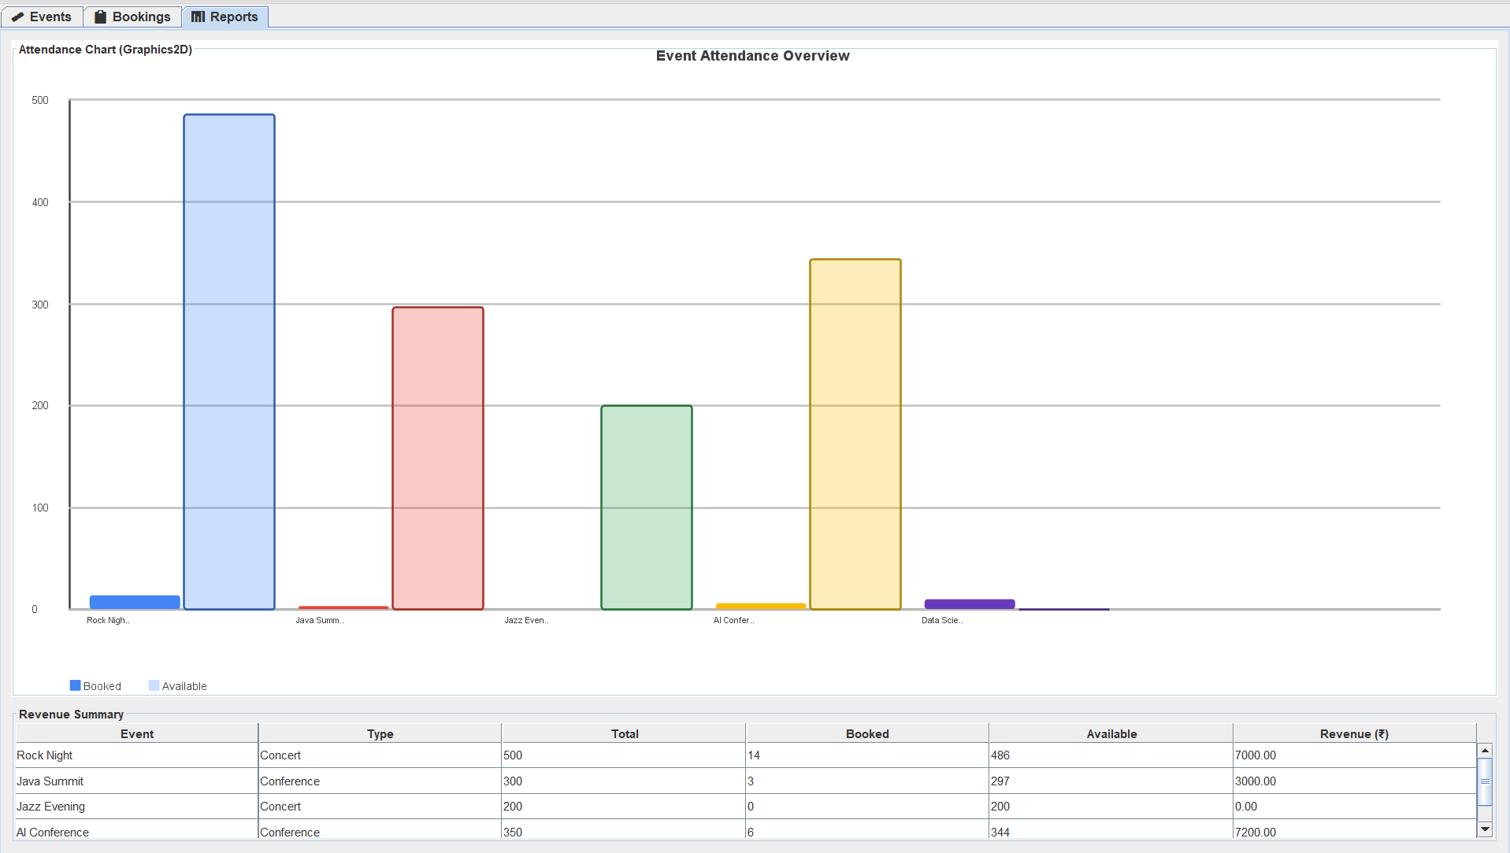
Figure 6: Reports Tab: the custom AttendanceChartPanel renders a paired-bar chart (solid = booked, translucent = available) for every event using Graphics2D with anti-aliasing.

3.7 Console Output — Concurrent Booking Thread Test
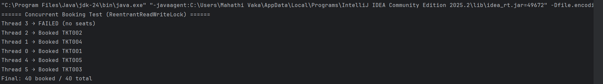Six threads each attempting 8 seats against a 40-seat event. Five succeed (5 x 8 = 40) and Thread 5 is correctly denied. Thread scheduling is non-deterministic, so thread order may vary between runs, but the final tally is always exactly 40 booked.

3.8 Save and Load — Serialization

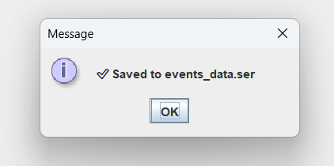

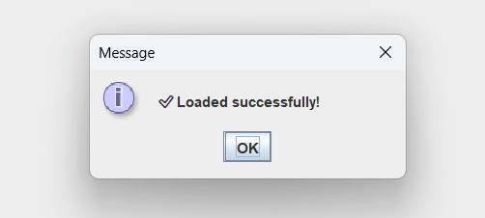
Figure 7: After clicking File > Save Events, a JOptionPane confirms 'Saved to events_data.ser'. File > Load Events deserializes the file and repopulates both the Events and Bookings tables.

4. UNIT-WISE CONCEPT COVERAGE SUMMARY

The table below confirms which Java concepts from each prescribed unit have been implemented in the Event Management Platform.

Unit | Concept Required | Implemented | Class / Method Name
Unit 1 | Classes, constructors, overloading, arrays, type casting, flow control | Yes | BaseEvent, Venue, Ticket, Attendee constructors; seatCapacity int[]; (double) cast; if-else in bookTicket()
Unit 2 | Byte/character streams, file I/O, ObjectOutputStream, Java Bean standards | Yes | EventRegistry.serializeToFile(), deserializeFromFile(); EventStorage.save()/load(); all domain classes follow Bean conventions
Unit 3 | Inheritance, abstract classes, interfaces, exceptions, wrapper classes | Yes | BaseEvent (abstract); Bookable, Cancellable (interfaces); ConcertEvent, ConferenceEvent (extends); NumberFormatException caught; Integer.parseInt(), Double.parseDouble()
Unit 4 | Threads, synchronisation, ReentrantReadWriteLock, annotations | Yes | runConcurrentDemo() (Thread); BaseEvent.book()/cancel()/getAvailableSeats() (ReentrantReadWriteLock); @Override, @SuppressWarnings
Unit 5 | Swing GUI, collections (List/Map/Set), generics, Graphics2D | Yes | JFrame, JTabbedPane, JTable, JDialog, JProgressBar, JOptionPane (Swing); HashMap<String,TreeSet<Attendee>>, ArrayList<>, generics; AttendanceChartPanel (Graphics2D)

5. CONCLUSION

Developing the Event Management Platform provided a comprehensive understanding of how the five units of Java Programming integrate into a cohesive application. The most challenging aspect was combining concurrency with Swing, as the graphical interface operates on the Event Dispatch Thread while booking operations require thread-safe execution. The use of ReentrantReadWriteLock ensured data consistency during concurrent access.

This project enhanced my understanding of Java’s threading model, particularly the need to manage UI updates using SwingUtilities.invokeLater(). Additionally, implementing object serialization highlighted the importance of handling transient fields through custom deserialization methods.

Given more time, the system could be improved by incorporating an ExecutorService for better thread management, adding search functionality to enhance usability, and replacing binary serialization with JSON-based persistence for improved flexibility. Overall, the project strengthened my practical understanding of core Java concepts and their real-world application..

6. REFERENCES
- [1] H. Schildt, Java: The Complete Reference, 11th ed. New York, NY: Oracle Press / McGraw-Hill, 2019.
- [2] C. S. Horstmann, Core Java Volume I — Fundamentals, 11th ed. Upper Saddle River, NJ: Prentice Hall, 2018.
- [3] C. S. Horstmann, Core Java Volume II — Advanced Features, 11th ed. Upper Saddle River, NJ: Prentice Hall, 2018.
- [4] Oracle Corporation, "Java SE 17 API Documentation," Oracle, 2021. [Online]. Available: https://docs.oracle.com/en/java/javase/17/docs/api/
- [5] Oracle Corporation, "The Java Tutorials: Concurrency," Oracle, 2022. [Online]. Available: https://docs.oracle.com/javase/tutorial/essential/concurrency/
- [6] Oracle Corporation, "The Java Tutorials: Object Serialization," Oracle, 2022. [Online]. Available: https://docs.oracle.com/javase/tutorial/jndi/objects/serial.html
- [7] B. Eckel, Thinking in Java, 4th ed. Upper Saddle River, NJ: Prentice Hall, 2006.

